Amanda Tirey
Module 2.2 Debugging
Screenshot 1
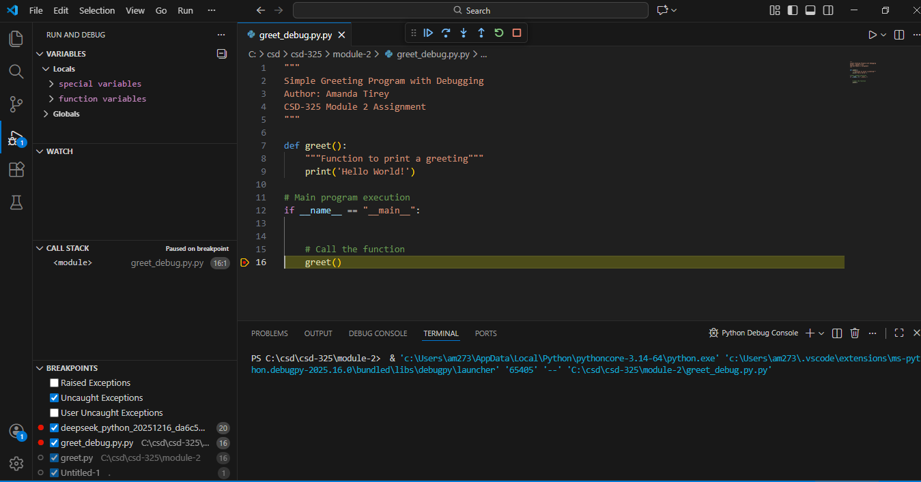
Screenshot 2
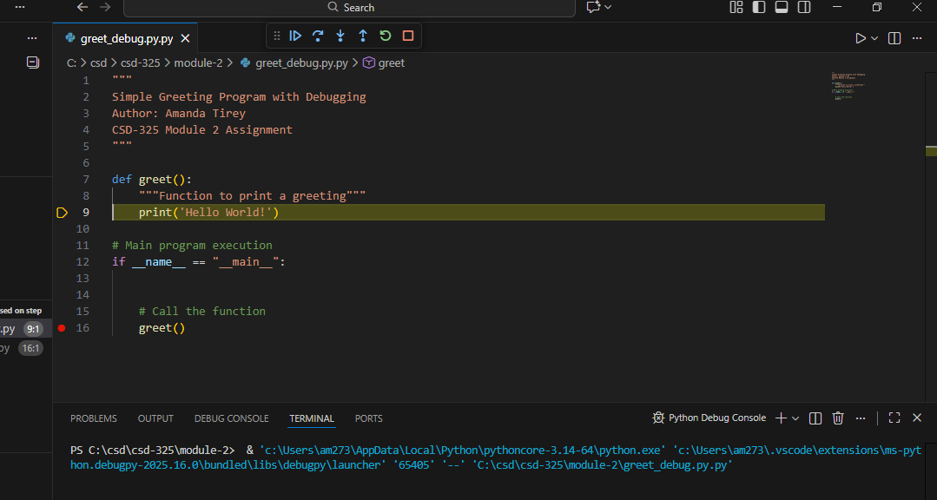
Screenshot 3
